**Sourcewise delivers 500 Farmers’ Market Nutrition Vouchers to eligible seniors in Santa Clara County**

**San Jose, July 17, 2017:**  Sourcewise distributed 500 voucher booklets to qualifying low income seniors in Santa Clara County. The annual Senior Farmers’ Market Nutrition Program began on June 12, 2017. Qualified Santa Clara County seniors received vouchers worth a total of $20.00 for the purchase of locally grown produce at participating Certified Farmers’ Markets.

The Seniors Farmers’ Market Nutrition Program is a federal program that promotes healthy aging by helping seniors, ages 60 and older, who meet low-income eligibility requirements, supplementing their diets with fresh fruits, vegetables, and fresh-cut herbs while also supporting small, California farmers.

Participants receive nutritional information: tips on how to eat more vegetables, how to prepare and store vegetables, and how to shop at farmers’ markets to get the most from a limited budget.

“The ongoing partnership with the California Department of Food and Agriculture encourages health, wellness, and provides us with a unique opportunity to better serve the needs of seniors in Santa Clara County,” says Manuel Altamirano, Chief Operating Officer at Sourcewise.

To deliver this program to those who need it most, Sourcewise carefully selected and partnered with central distribution points throughout Santa Clara County.

Sourcewise 2017 Farmers’ Market Voucher Tour Schedule:

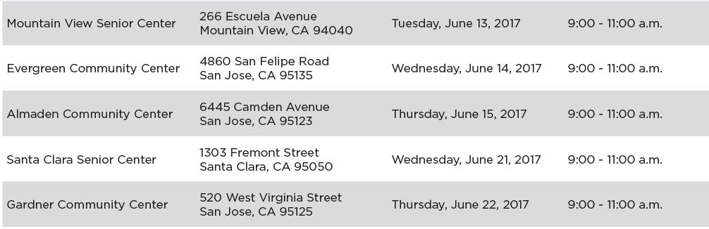

  *All distribution points were within 2 miles of a farmers’ market.

“The Senior Farmers Market Nutrition Program impacted our site in a positive way, as many people came in to our [center] who may not have come if the vouchers were not distributed at our site. It was a great way to connect with new people to share our programs and resource,” said a senior/community center representative.

To learn more about the Senior Farmers Market Nutrition Program, please visit [www.mysourcewise.com](http://www.mysourcewise.com). Sourcewise is a 501(c)(3) nonprofit organization with over 40 years of experience serving Santa Clara County residents.

############################

Contact Info:

Aneliza Del Pinal

Director, Public Relations

(408) 557-4701

[adelpinal@mysourcewise.com](mailto:adelpinal@mysourcewise.com)

*We welcome the re-use, republication, and distribution of Sourcewise content. Please credit us with the following information: Used with the permission of http://www.mysourcewise.com.*