**Sourcewise unveils Community Education Series for 2019 Medicare changes to all Santa Clara County residents**

**San Jose, October 1, 2018:**As the first to pilot the nationwide network of insurance assistance programs, the Health Insurance Counseling and Advocacy program is a leader in delivering objective information and assistance to those persons who have questions about Medicare.

Beginning October 12, 2018, the Sourcewise Health Insurance Counseling & Advocacy program (HICAP) launches its 2019 Annual Enrollment Period Educational Series. The program helps Santa Clara County Medicare enrollees identify any changes to their plans, the options available, and how to execute their plan choices.

Prior to and during the Annual Enrollment Period of October 15 to December 7, beneficiaries should be aware of:

* Medicare Prescription Drug Plan costs and formulary changes for 2019
* Medicare Advantage Plan costs and benefits for 2019
* Enrollment timing and rights to change plans, including the reinstated Medicare
* Advantage Open Enrollment from January through March each year beginning in 2019

 “In Santa Clara County there are 25 HMO plans offered by 10 health care plans. It can be confusing for folks to navigate, especially since plans, benefits, and costs change yearly” explains Marcelo Espiritu, Product Analyst for the Health Insurance Counseling & Advocacy Program.

Learn about Medicare Options for 2019 at convenient locations in Santa Clara County:

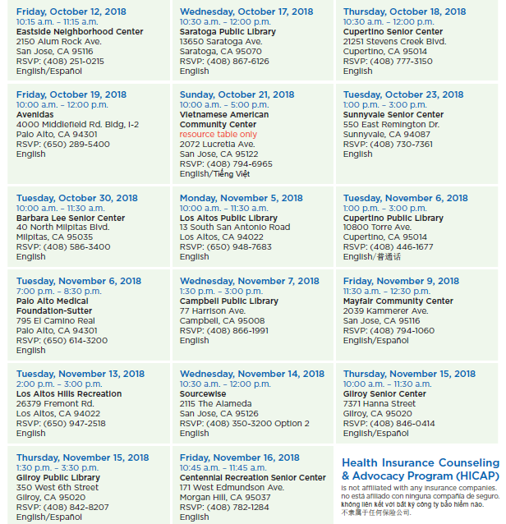

“Thank you again for your generosity of time and your kindness of spirit in helping me to decide on Medicare supplemental plans in September. I so appreciated both your health insurance wisdom and your thoughtful follow-up research,” shared a Santa Clara resident about her experience with one of the program’s counselors.

Through personalized counseling sessions and community education, counselors help their clients make informed decisions about their health benefits. HICAP counselors are available year around to assist with comparison charts, insurance plan benefits, claim or benefit denials, and other health insurance related billing questions .

 The Sourcewise Health Insurance Counseling & Advocacy Program does not sell, endorse, nor represent any insurance company. Sourcewise is a 501(c)(3) nonprofit organization with 45 years of experience serving the residents of Santa Clara County.

######

Contact Info: Aneliza Del Pinal

Director, Public Relations

(408) 557-4701

adelpinal@mysourcewise.com

*We welcome the re-use, republication, and distribution of Sourcewise content. Please credit us with the following information: Used with the permission of http://mysourcewise.com*