**Sourcewise dominates State service program, seniors connected to local farmers markets**

**San Jose, August 21, 2018:** The Sourcewise Seniors Farmers’ Market Program had the highest redemption rate in California for 2017, nearly 90%, according to the California Department of Food and Agriculture. This makes the Sourcewise program the most successful in the state. While the results for the 2018 delivery are not in yet, Sourcewise anticipates once again being equally successful.

The focus of the Senior Farmers’ Market Program is to provide access to free, nutritious options for low-income seniors, ages 60 years and older. A 2014 report by the Santa Clara County Public Health department revealed that only 22% of older adults (65+) report eating at least five servings of fruit and vegetables daily.

“Seniors are having difficulty acquiring adequate supply to meet their nutritional needs. Our program empowers individuals to make healthy choices while also supporting local farmers,” explains Henri Villalovoz, who leads this effort on behalf of Sourcewise.

In addition to the vouchers, participants receive nutritional education: how to eat more vegetables, how to prepare and store vegetables, and how to shop at farmers’ markets to get the most from a limited budget.

To deliver vouchers to residents with limited resources, Sourcewise strategically chose central distribution points with nearby access to public transportation. Distribution points were also located near farmers’ markets. A total of twenty-four farmers markets are certified for voucher redemption within Santa Clara County.

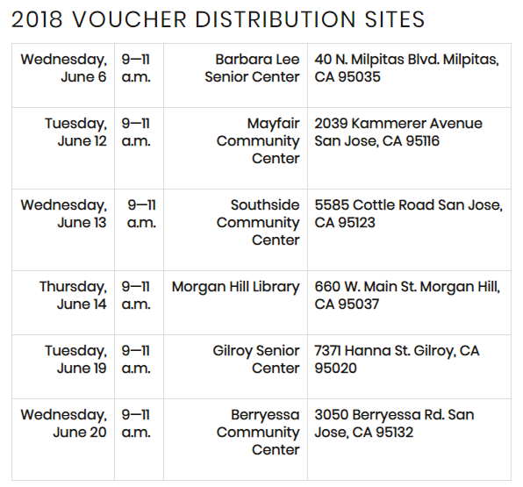

“This program is a blessing! Thank you for being here. The staff is very kind and approachable. It is very difficult to put on a large event…you were even able to accommodate for multiple languages,” shared Sally W., a 2018 voucher recipient.

Sourcewise, in partnership with the California Department of Food and Agriculture, distributed 500 voucher booklets to qualifying seniors in Santa Clara County. Through the Seniors Farmers’ Market Program, individuals received vouchers worth $20.00, redeemable for fresh fruits, vegetables, and fresh-cut herbs throughout the harvest season, June through November 2018.

To learn more about the Senior Farmers’ Market Nutrition Program or how you can support Sourcewise with a donation, please visit [www.mysourcewise.com](http://www.mysourcewise.com). Sourcewise is a 501(c)(3) nonprofit organization with over 40 years of experience serving Santa Clara County residents.

######

Contact Info:

Aneliza Del Pinal

Director, Public Relations

(408) 557-4701

[adelpinal@mysourcewise.com](mailto:adelpinal@mysourcewise.com)

*We welcome the re-use, republication, and distribution of Sourcewise content. Please credit us with the following information: Used with the permission of http://www.mysourcewise.com.*