SOURCEWISE VOLUNTEERS CONTINUE TO SUPPORT VULNERABLE SENIORS

They Provide ESSENTIAL and Needed Support
Published by City of San José on December 23, 2020 at 9:00 a.m.
*This is a special feature from the City of San Jose, Department of Parks, Recreation and Neighborhood Services
“The holidays can be a difficult time if you’re alone. We know that there's a lot of anxiety, depression and suicidal ideation that comes with social isolation from social distancing,” said Linda Phillips, Director of Community Development at Sourcewise. “We’re hoping that these conversations with volunteers help reduce the negative impacts of social isolation for seniors.”
Sourcewise Community Resource Solutions and participating volunteers are on a mission to ensure that Santa Clara County’s senior community is being supported during this challenging holiday season.
Due to county guidelines to protect residents from the pandemic, there has been adverse effects. Many members of the vulnerable senior population are homebound, losing access to food resources and being disconnected from friends and family.
Through their Meals on Wheels (MOW) and new Ambassador program, Sourcewise is committed to not only providing homebound seniors with essential meals, but necessary companionship.
The Ambassador program connects volunteers to registered seniors for phone call conversations, helping participants feel connected during a time of isolation.
After completing online training, volunteers are asked to commit to at least one hour of phone calls a week for two months or more. Phone calls are typically 10-15 minute friendly conversations, providing participating seniors with crucial person-to-person connection.
“We know that social isolation is detrimental to our seniors,” Phillips added. “We want to make sure our volunteers are providing them with emotional support.”
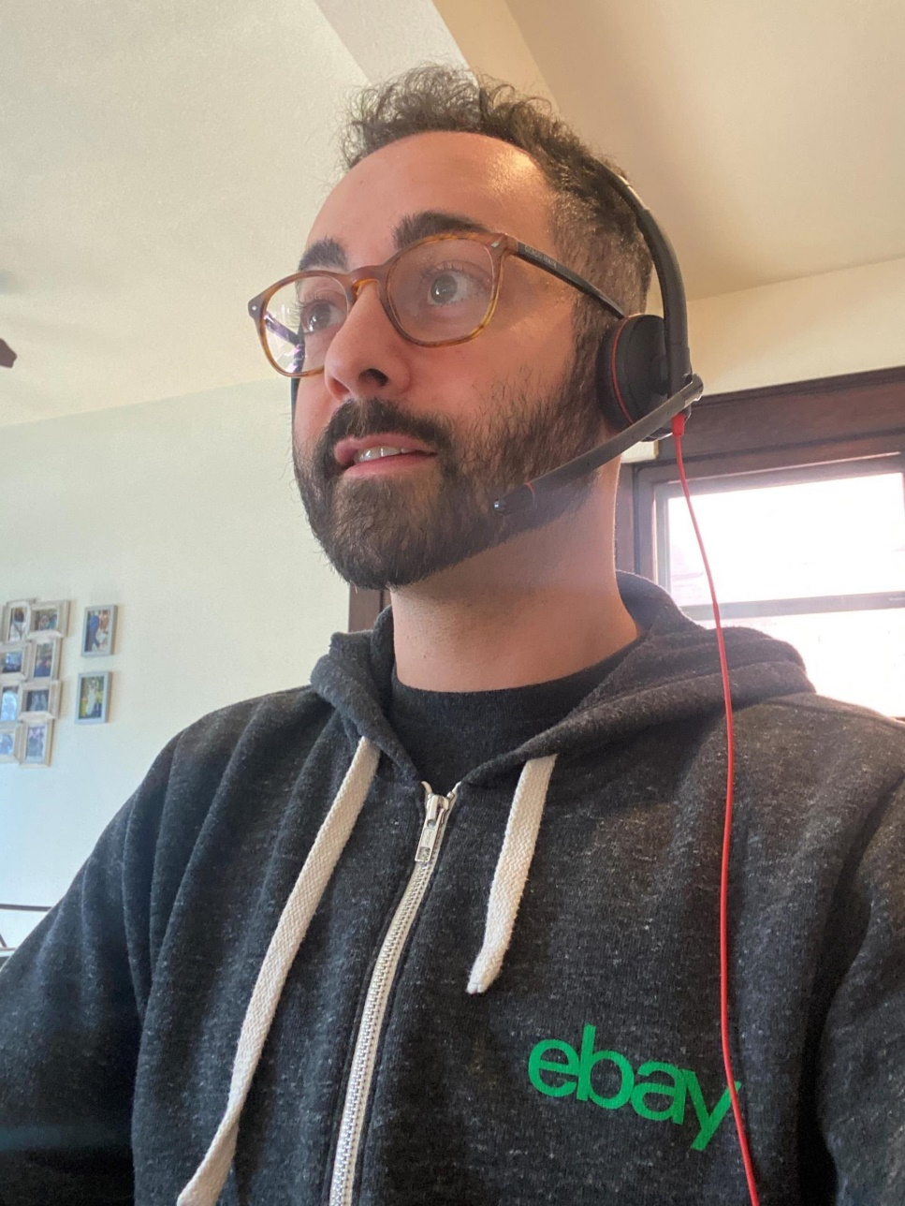
Ambassador calls can be as brief as 10 minutes, but ultimately provide seniors with essential daily social interaction. Photo courtesy of Bahaa Chmait, a local eBay employee volunteer and Sourcewise Ambassador
Currently, Sourcewise provides 14 meals a week to seniors registered in their MOW program who do not have access to food.
Through these efforts, Sourcewise volunteers are supporting some of the most at-risk members of our community by providing them with the tools and support they need for their physical and mental health, while keeping safety a top priority.
Sourcewise recognizes the growing need for aid and plans to extend their volunteer programs beyond the holiday season and into 2021.
“We are going to continue as long as there’s a need to continue recruiting our ESSENTIAL volunteers for these homebound seniors,” said Phillips.
Your help is needed now. For more information on becoming a Sourcewise volunteer, go to mysourcewise.com/commitment.
It's also not too late to volunteer for the holidays! Volunteers helping nonprofits distribute food necessities are allowed under the current stay-at-home order.
Each nonprofit organization will be able to provide information about their COVID-19 compliance policies and procedures. #SiliconValleyStrong
Sign up for a volunteer opportunity (below) or submit an application to volunteer at SV Strong: siliconvalleystrong.org/volunteer/
View the City of San José article here.

