Attend Sourcewise Community Education Presentations to Learn More About 2022 Medicare Updates

Santa Clara, October 1, 2021: Medicare’s Annual Enrollment Period (AEP) runs every year from October 15 to December 7. The Sourcewise Health Insurance Counseling & Advocacy Program (HICAP) will launch their virtual presentation series called “Medicare’s 2021 Annual Enrollment Period and Updates for 2022”, both via Zoom and in person. HICAP provides one-on-one confidential, free, and unbiased counseling for the open enrollment period for individuals to change or modify Medicare insurance plans.
“The AEP is a chance for Medicare recipients to make sure they have access to their needed physicians, therapist, facilities, and medications for the upcoming year. They must evaluate what they pay for and what they gain or give up in return. Recipients may want the broader physician/provider choice of Original Medicare and a more affordable drug plan. Others may prefer Managed Medicare through an Advantage Plan and the extra benefits not found in Original Medicare. Monthly premiums, deductibles and copays often change but rarely decrease. HICAP Counselors can help Medicare recipients navigate their Medicare arrangement to best suit their changing needs,” explains Marcelo Espiritu, Director of HICAP.
During AEP, Medicare recipients should be aware of:
- Medicare Prescription Drug Plan costs and formulary changes for 2022
- Medicare Advantage Plan costs and benefits for 2022
- Enrollment timing and rights to change plans, including the Medicare Advantage Open Enrollment from January through March each year

“HICAP Counselors assist people of all socioeconomic backgrounds. We [HICAP Counselors] also help people in the language they are comfortable speaking, either with one of our bilingual HICAP Counselors or with an interpreter over the phone” Marcelo continues to share.
Visit the Sourcewise Online Event Calendar and register to attend one of the webinars.
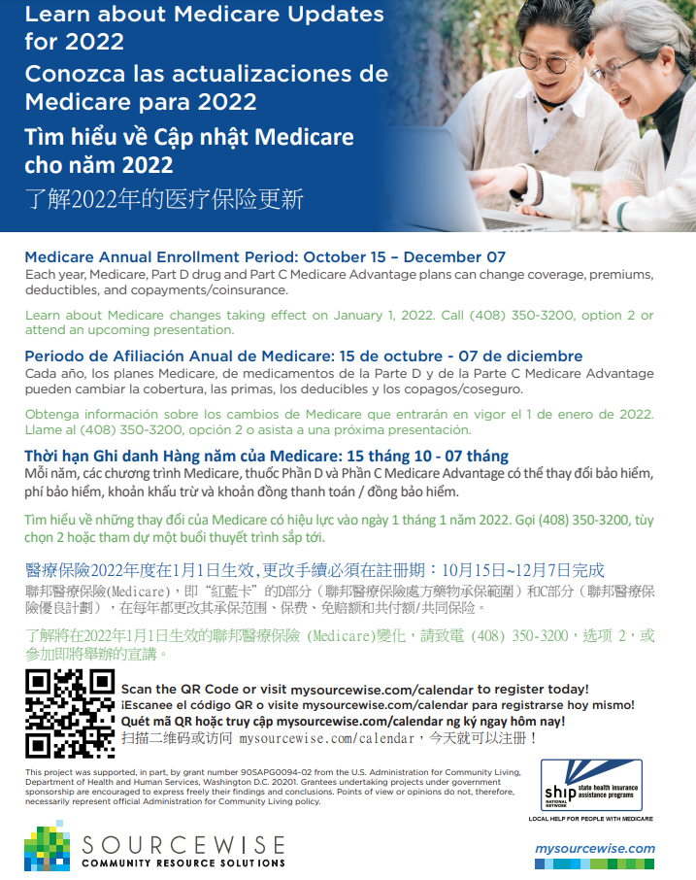
All year-round, you can receive personalized Medicare counseling and community education services. HICAP Counselors help individuals, their families, and caregivers’ transition into Medicare and solve other health insurance issues that may occur throughout the year.
Contact information:
Information & Awareness
(408) 350-3200, option 1
community@mysourcewise.com

